Ansible Task Control — Complete Practical Lab

Your environment
Control Node:
ansible@localhost

Inventory:
/etc/ansible/hosts

Group:
dev1

Managed Hosts:
ansibleclient1
ansibleclient2

OS:
Ubuntu 26.04 LTS
We will cover:
- Task control
- Loops
- Installing multiple packages using loops
- Loop with a variable list
- List of dictionaries
- Looping through dictionary lists
- register with loops

1. Task Control in Ansible

What is task control?
Task control means controlling how and when Ansible tasks execute.
Common task-control features:
when → Run task only when condition is true
loop → Repeat a task
register → Store task result
We will learn these practically.

PART 1 — Loop

2. Task Iteration with Loops
A loop repeats the same task multiple times.

Example: Create multiple users
We will create:
devuser1
devuser2
devuser3

Step 1: Go to your Ansible directory
cd /home/ansible

Step 2: Create playbook
vi create-users.yml
Put:
---
- name: Create multiple users
hosts: dev1
become: true

tasks:
- name: Create users
ansible.builtin.user:
name: "{{ item }}"
state: present
loop:
- devuser1
- devuser2
- devuser3

Step 3: Syntax check
ansible-playbook -i /etc/ansible/hosts create-users.yml --syntax-check
Expected:
playbook: create-users.yml

Step 4: Run
ansible-playbook -i /etc/ansible/hosts create-users.yml
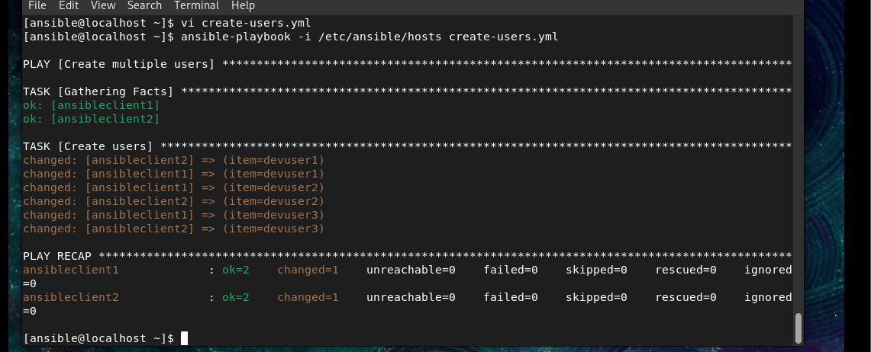
You should see:
changed: [ansibleclient1] => (item=devuser1)
changed: [ansibleclient1] => (item=devuser2)
changed: [ansibleclient1] => (item=devuser3)

changed: [ansibleclient2] => (item=devuser1)
changed: [ansibleclient2] => (item=devuser2)
changed: [ansibleclient2] => (item=devuser3)

Step 5: Verify
ansible -i /etc/ansible/hosts dev1 -m command -a "id devuser1"
You can also check:
ansible -i /etc/ansible/hosts dev1 -m command -a "id devuser2"
ansible -i /etc/ansible/hosts dev1 -m command -a "id devuser3"

What happened?
loop
↓
devuser1 → create
devuser2 → create
devuser3 → create
item represents the current value.
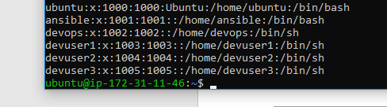

PART 2 — Installing Multiple Packages Using Loops
Because your clients are Ubuntu, we use apt.
We will install:
git
vim
curl

Step 1: Create playbook
vi packages-loop.yml
Put:
---
- name: Install multiple packages
hosts: dev1
become: true

tasks:
- name: Install packages
ansible.builtin.apt:
name: "{{ item }}"
state: present
update_cache: true
loop:
- git
- vim
- curl

Step 2: Syntax check
ansible-playbook -i /etc/ansible/hosts packages-loop.yml --syntax-check

Step 3: Run
ansible-playbook -i /etc/ansible/hosts packages-loop.yml
Ansible effectively does:
apt install git
apt install vim
apt install curl
for both:
ansibleclient1
ansibleclient2

Step 4: Verify
ansible -i /etc/ansible/hosts dev1 -m command -a "git --version"
ansible -i /etc/ansible/hosts dev1 -m command -a "vim --version"
ansible -i /etc/ansible/hosts dev1 -m command -a "curl --version"
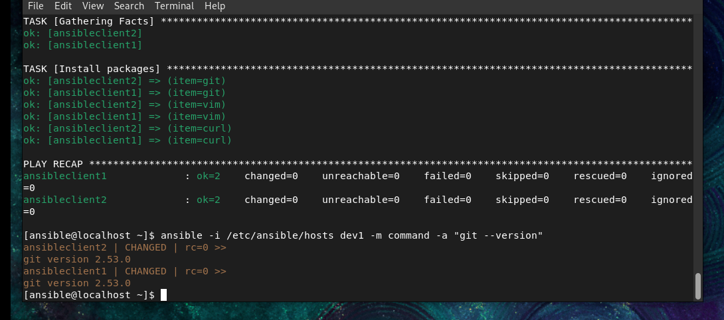

PART 3 — Loop With a Variable List
Instead of putting the list directly inside the task, we can create a variable containing the list.

Step 1: Create playbook
vi packages-variable.yml
Put:
---
- name: Install packages using variable
hosts: dev1
become: true

vars:
packages:
- git
- vim
- curl

tasks:
- name: Install packages
ansible.builtin.apt:
name: "{{ item }}"
state: present
loop: "{{ packages }}"
Notice:
vars:
packages:
- git
- vim
- curl
This is a list variable.
Then:
loop: "{{ packages }}"
means:
Loop through the values stored inside packages.

Step 2: Run
ansible-playbook -i /etc/ansible/hosts packages-variable.yml
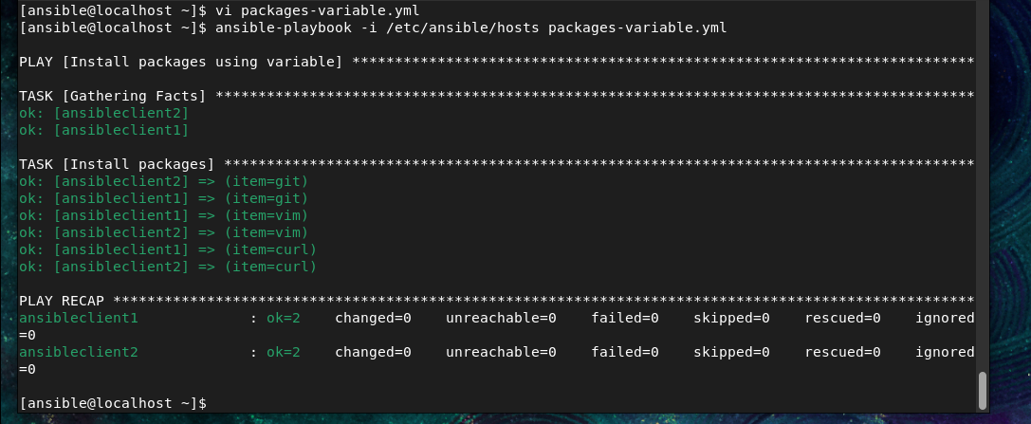

PART 4 — List of Dictionaries
Now we make it slightly more advanced.
A dictionary contains key-value pairs.
Example:
name: Rahul
shell: /bin/bash
A list of dictionaries means multiple dictionaries inside a list.
Example:

users:
- name: rahul
shell: /bin/bash

- name: amit
shell: /bin/bash

- name: priya
shell: /bin/bash
Think of it like:
users
│
├── user 1
│ ├── name = rahul
│ └── shell = /bin/bash
│
├── user 2
│ ├── name = amit
│ └── shell = /bin/bash
│
└── user 3
├── name = priya
└── shell = /bin/bash

PART 5 — Practical List of Dictionaries
We will create three users with different shells.

Step 1: Create playbook
vi users-dictionary.yml
Put:
---
- name: Create users using dictionaries
hosts: dev1
become: true

vars:
users:
- name: rahul
shell: /bin/bash

- name: amit
shell: /bin/sh

- name: priya
shell: /bin/bash

tasks:
- name: Create users
ansible.builtin.user:
name: "{{ item.name }}"
shell: "{{ item.shell }}"
state: present
loop: "{{ users }}"

Step 2: Syntax check
ansible-playbook -i /etc/ansible/hosts users-dictionary.yml --syntax-check

Step 3: Run
ansible-playbook -i /etc/ansible/hosts users-dictionary.yml
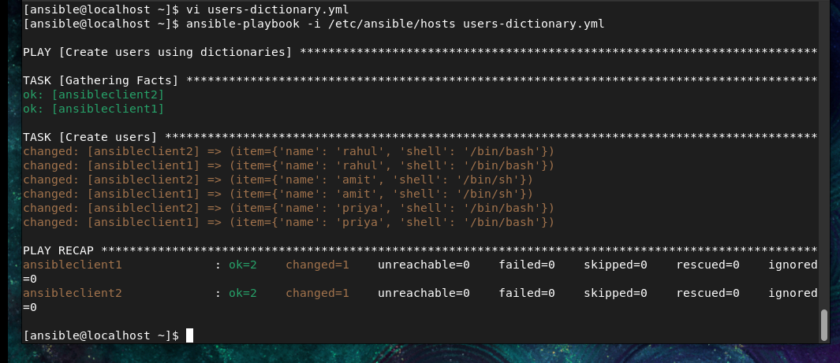
Ansible processes:
rahul → /bin/bash
amit → /bin/sh
priya → /bin/bash
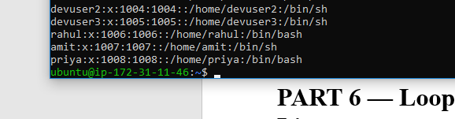

PART 6 — Looping Through Dictionary Lists
The important part is:
"{{ item.name }}"
and:
"{{ item.shell }}"
For the first iteration:
item.name = rahul
item.shell = /bin/bash
Second:
item.name = amit
item.shell = /bin/sh
Third:
item.name = priya
item.shell = /bin/bash
So:
name: "{{ item.name }}"
means:
Get the name value from the current dictionary.
And:
shell: "{{ item.shell }}"
means:
Get the shell value from the current dictionary.

PART 7 — Verify Dictionary Users
Check Rahul:
ansible -i /etc/ansible/hosts dev1 -m command -a "getent passwd rahul"
Check Amit:
ansible -i /etc/ansible/hosts dev1 -m command -a "getent passwd amit"
Check Priya:
ansible -i /etc/ansible/hosts dev1 -m command -a "getent passwd priya"
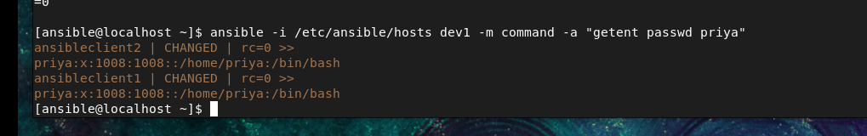

PART 8 — Register in Ansible
Now let's learn register.

What is register?
register stores the result of a task in a variable.
Example:
- name: Check hostname
ansible.builtin.command: hostname
register: hostname_result
The result is stored inside:
hostname_result

PART 9 — Practical Register Example

Step 1: Create playbook
vi register-example.yml
Put:
---
- name: Register example
hosts: dev1

tasks:
- name: Check hostname
ansible.builtin.command: hostname
register: hostname_result

- name: Display hostname result
ansible.builtin.debug:
var: hostname_result

Step 2: Run
ansible-playbook -i /etc/ansible/hosts register-example.yml
Ansible runs:
hostname
and stores the result in:
hostname_result
Then the debug task displays it.
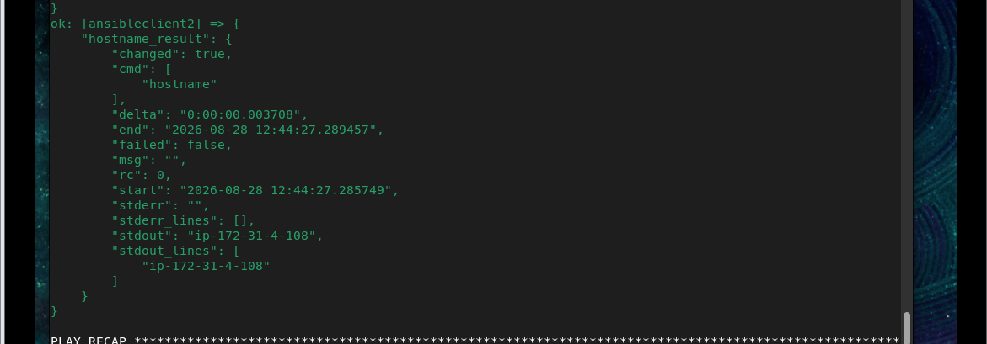

PART 10 — Register With Loop
This is very important.
We will check whether several users exist.

Step 1: Create playbook
vi register-loop.yml
Put:
---
- name: Register with loop
hosts: dev1

tasks:
- name: Check users
ansible.builtin.command: "id {{ item }}"
loop:
- rahul
- amit
- priya
register: user_results

- name: Display results
ansible.builtin.debug:
var: user_results

Step 2: Run
ansible-playbook -i /etc/ansible/hosts register-loop.yml
Ansible executes:
id rahul
id amit
id priya
The results are stored in:
user_results
Because we used a loop, the individual results are inside:
user_results.results
Think:
register
↓
user_results
↓
results
├── result for rahul
├── result for amit
└── result for Priya
